Project Design Phase
Solution Architecture
Date | 14 October 2026
Team ID
Project Name | Automated Network Request Management System
Maximum Marks | 4 Marks

Solution Architecture:
Solution architecture is a complex process – with many sub-processes – that bridges the gap between business problems and technology solutions. Its goals are to:
• Find the best tech solution to solve existing business problems.
• Describe the structure, characteristics, behavior, and other aspects of the software to project stakeholders.
• Define features, development phases, and solution requirements.
• Provide specifications according to which the solution is defined, managed, and delivered.
Example - Solution Architecture Diagram:
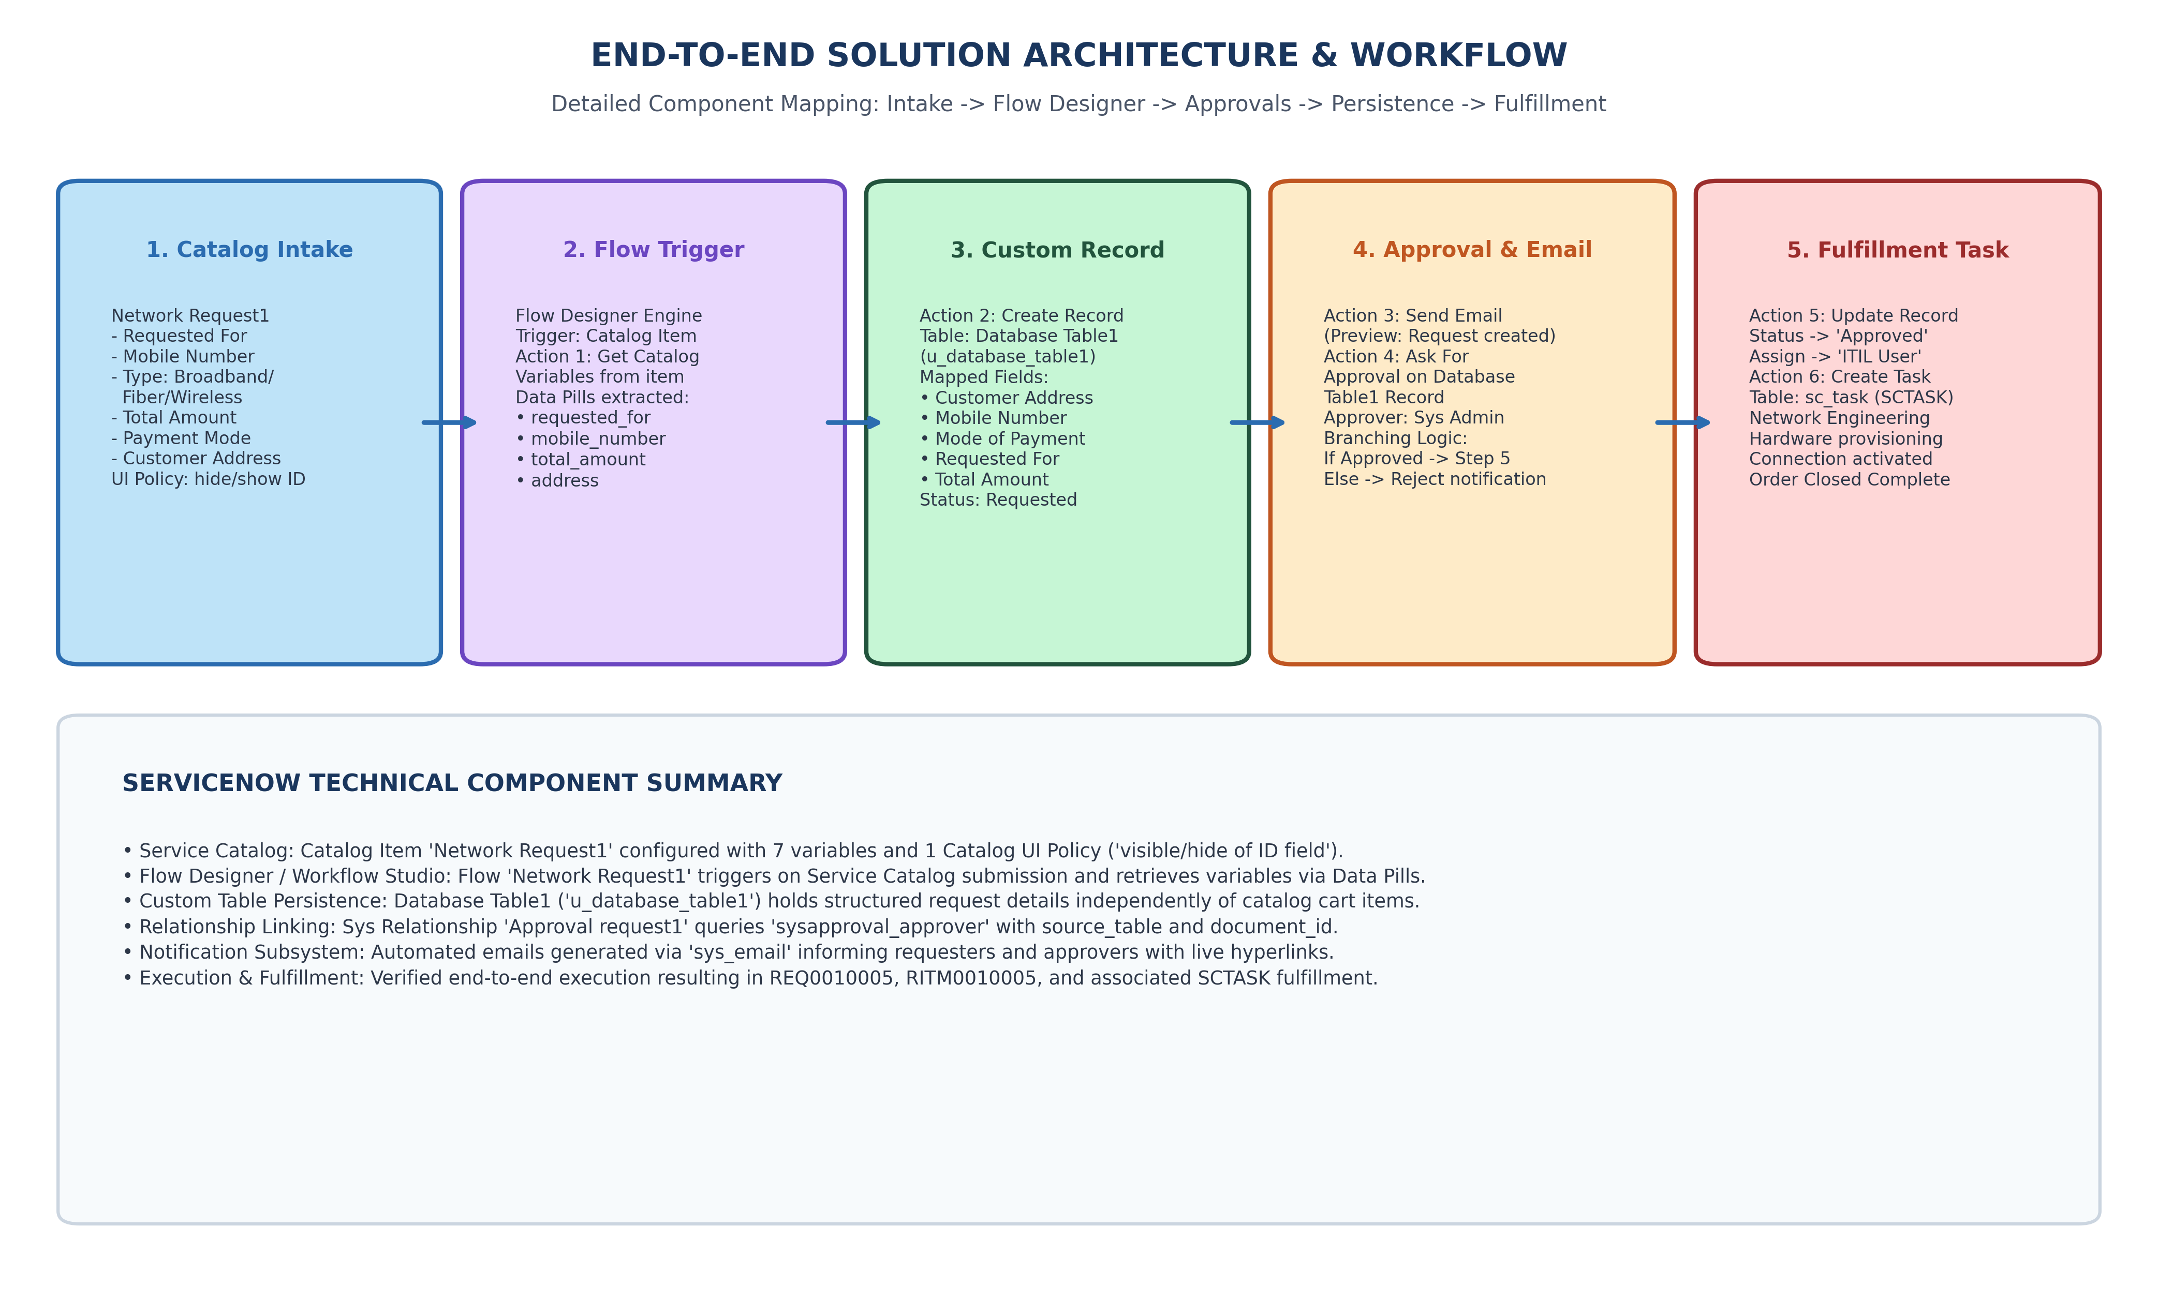
Figure 3.2: End-to-End Solution Architecture & Action Flow Diagram
Architecture Breakdown:
1. Service Catalog Intake: Catalog item 'Network Request1' with 7 variables and UI policy 'visible/hide of ID field'.
2. Flow Designer Engine: Triggers on catalog submission, retrieves variables via 'Get Catalog Variables' in 36ms.
3. Custom Persistence: 'Create Record' action logs data pills into Database Table1 (u_database_table1) in 18ms.
4. Governance & Approvals: 'Ask for Approval' action generates approval record on sysapproval_approver.
5. Decision Branching & Fulfillment: 'If Request is approved' updates table status to 'Approved', assigns to ITIL User, and creates Catalog Task (sc_task).

